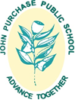
JOHN PURCHASE PUBLIC SCHOOL
Advance Together Strive for Excellence
Purchase Road, Cherrybrook NSW 2126
Phone: 9875 3100 Fax: 9875 3762
www.johnpurch-p.school@det.nsw.edu.au
e: johnpurch-p.school@det.nsw.edu.au

Kindergarten 2019 Stationery Requirements

Dear Parents and Carers

Please find below a list of stationery requirements for all kindergarten students in 2019. Please bring these to school during the first week in a labelled plastic bag.
- Long sleeve paint smock – labelled with name
- A small pair of child scissors – labelled with name
- Four hard glue sticks- may need replacing throughout the year. Glue sticks are to share – do not label with your child’s name. Large size “UHU” or “Bostik Blu” glue is recommended.
- One A4 plastic envelope labelled with name and class
- One box of tissues (optional)
- One roll of hand towel (optional)
- Four whiteboard markers- may need replacing throughout the year
- One whiteboard rubber/eraser (can be a cleaning cloth)
- Library bag – labelled with name and class
- A set of headphones packed into a small pencilcase, clearly labelled with your child’s name not ear buds (prong for iPad connection – not USB connection
- 12 pack or more crayon twistables. Crayons are to share and do not need to be labelled. (Crayola brand is recommended and available at Officeworks)

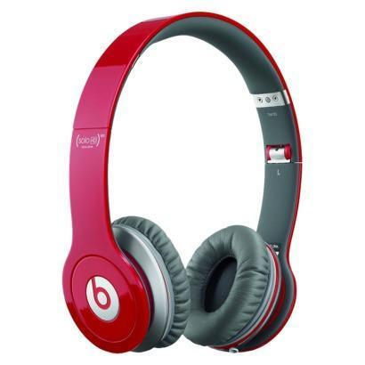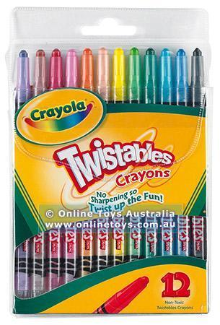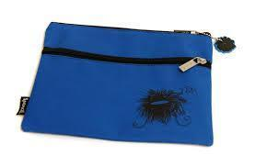

We ask that the whiteboard markers and erasers be put into a snap lock bag or a small pencil case, clearly labelled with your child’s name.
We thank you for your support.

The Early Stage One Teachers

